**DAILY ONLINE ACTIVITIES SUMMARY**

|  |  |  |  |  |  |  |  |  |
| --- | --- | --- | --- | --- | --- | --- | --- | --- |
| **Date:** | **20/07/2020** | | | | | **Name:** | **Shailashree** | |
| **Sem & Sec** | **IV sem & B section** | | | | | **USN:** | **4AL18CS077** | |
| **Online Test Summary** | | | | | | | | |
| **Subject** | | **COMPLEX ANALYSIS PROBABILITY AND STATISTICAL METHODS** | | | | | | |
| **Max. Marks** | | **30** | | **Score** | | | **-** | |
| **Certification Course Summary** | | | | | | | | |
| **Course** | **Predictive modeling and analysis** | | | | | | | |
| **Certificate Provider** | | | **Greatlearning academy** | | **Duration** | | | **2.5hours** |
| **Coding Challenges** | | | | | | | | |
| **Problem Statement1: --------------------------------------------------------------** | | | | | | | | |
| **Status: not Executed** | | | | | | | | |
| **Uploaded the report in Github** | | | | | **YES** | | | |
| **If yes Repository name** | | | | | **Daily Activity Report** | | | |
| **Uploaded the report in slack** | | | | | **YES** | | | |

Online Test Summary: Online Test Summary: 18MAT41 test was scheduled from 9:30 am t0 10:10 am And the test scores are not yet received. The portion for the IA was 1ST module there were 3 questions and the time assigned was 45 minutes the questions were written Type we have to write ans in A4 sheet and upload ans sheet as pdf document in google classroom in folder named as Descriptive test 1 .

Online Certification Course Summary: Today I started new course that Predictive modeling and analysis in Great Learning. In today’s session I have learnt about Best fit line and Multiple Regression.

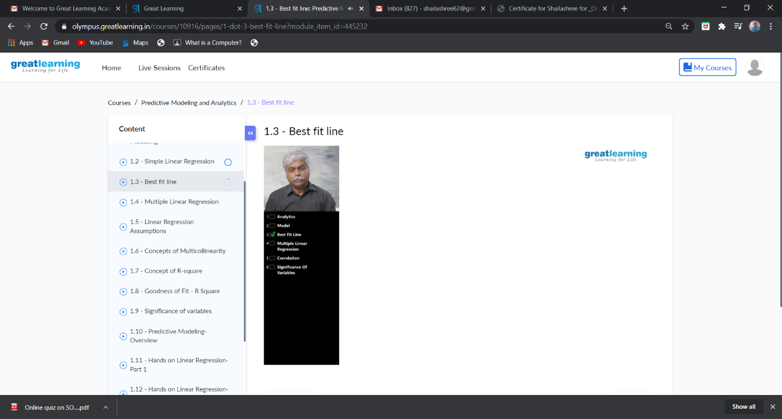

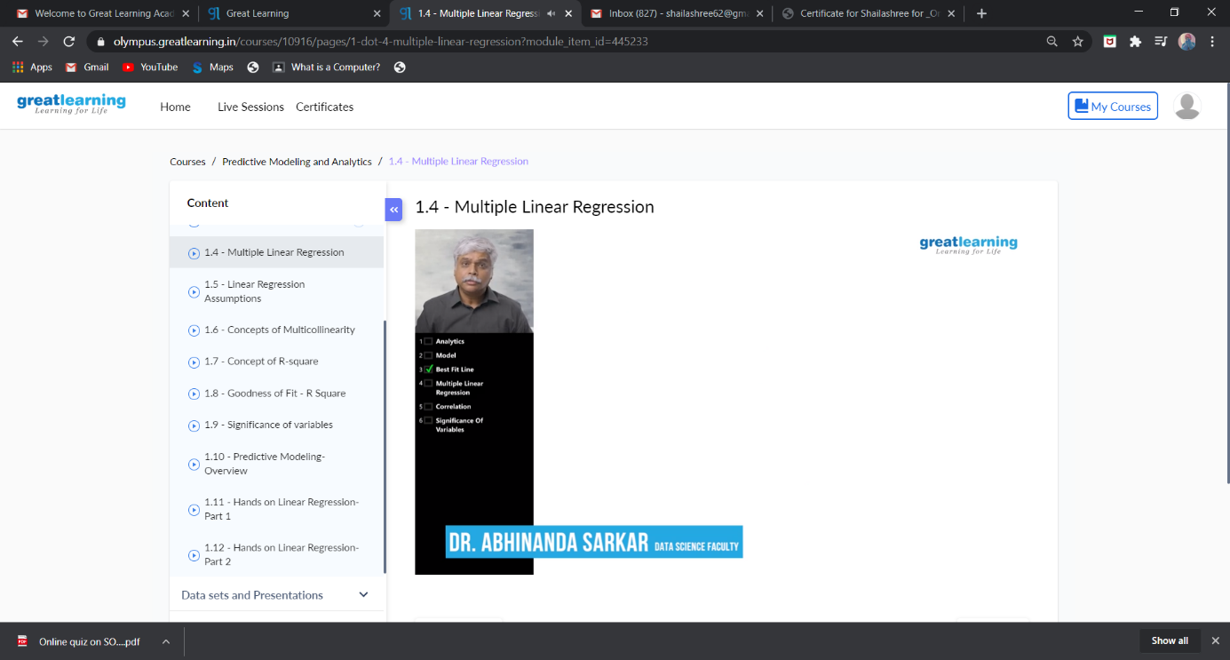

These are the snap shots of today’s sessions.

Online Coding Summary: **Today I had received one program from prof. Shilpa CSE Dept. The program is mentioned above in the coding challenges(pg.01). I have also uploaded it to my GitHub repository.**

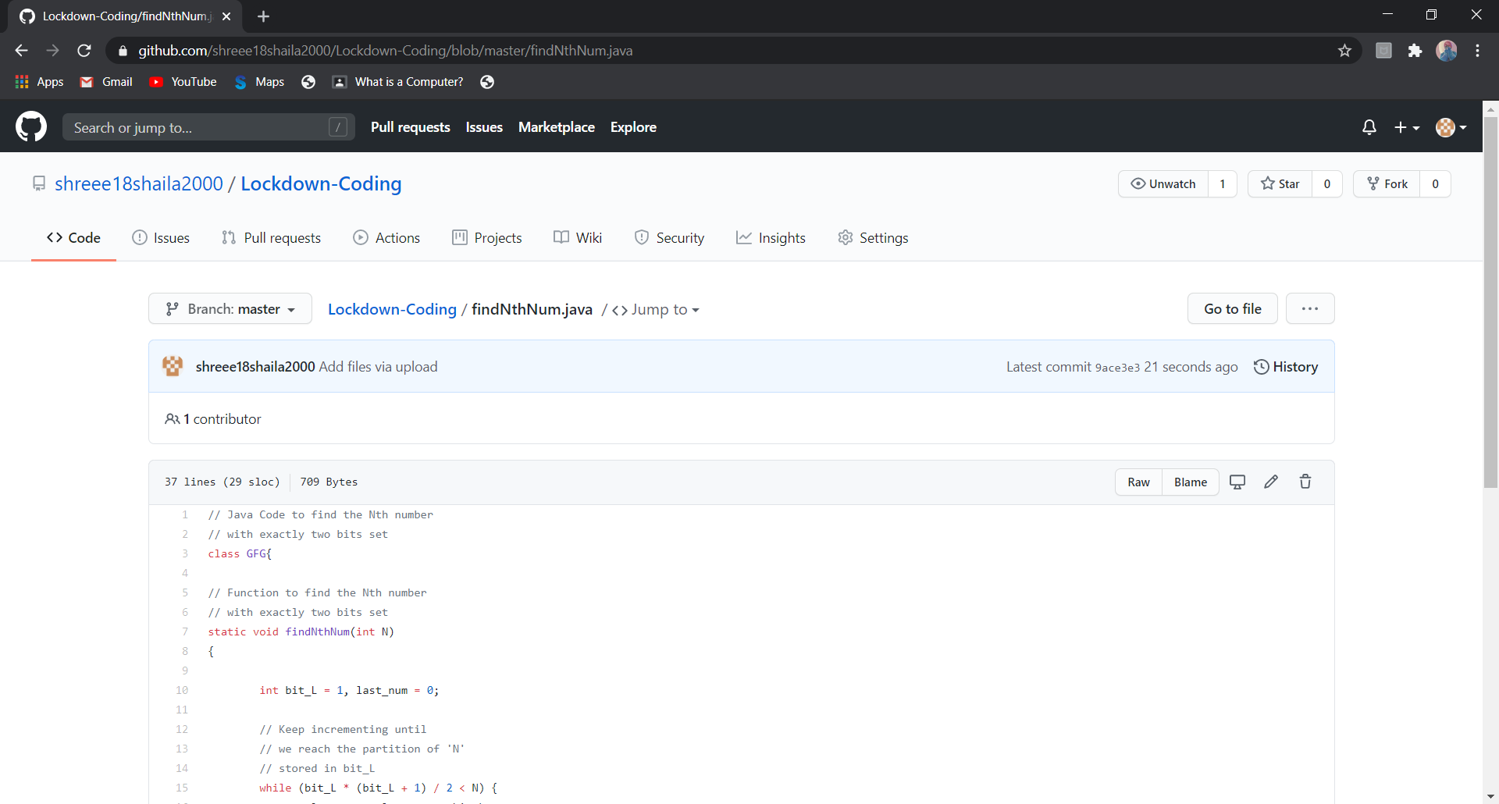

**This is the snap shot of my GitHub repository** where I have uploaded the code. File name is findNthNum.java.

Online Training: No training classes are conducted.